|  |  |
| --- | --- |
|  | Catholic Diocese of Bunbury  **SCREENING MATRIX** |

**SCREENING MATRIX – CATHOLIC DIOCESE OF BUNBURY**

The following matrix sets out the key roles within the Catholic Diocese of Bunbury and the screening requirements for each.

It is not an exhaustive list and should only be used as a guide.

# If unsure of screening requirements, please direct all queries to the Safeguarding Office.

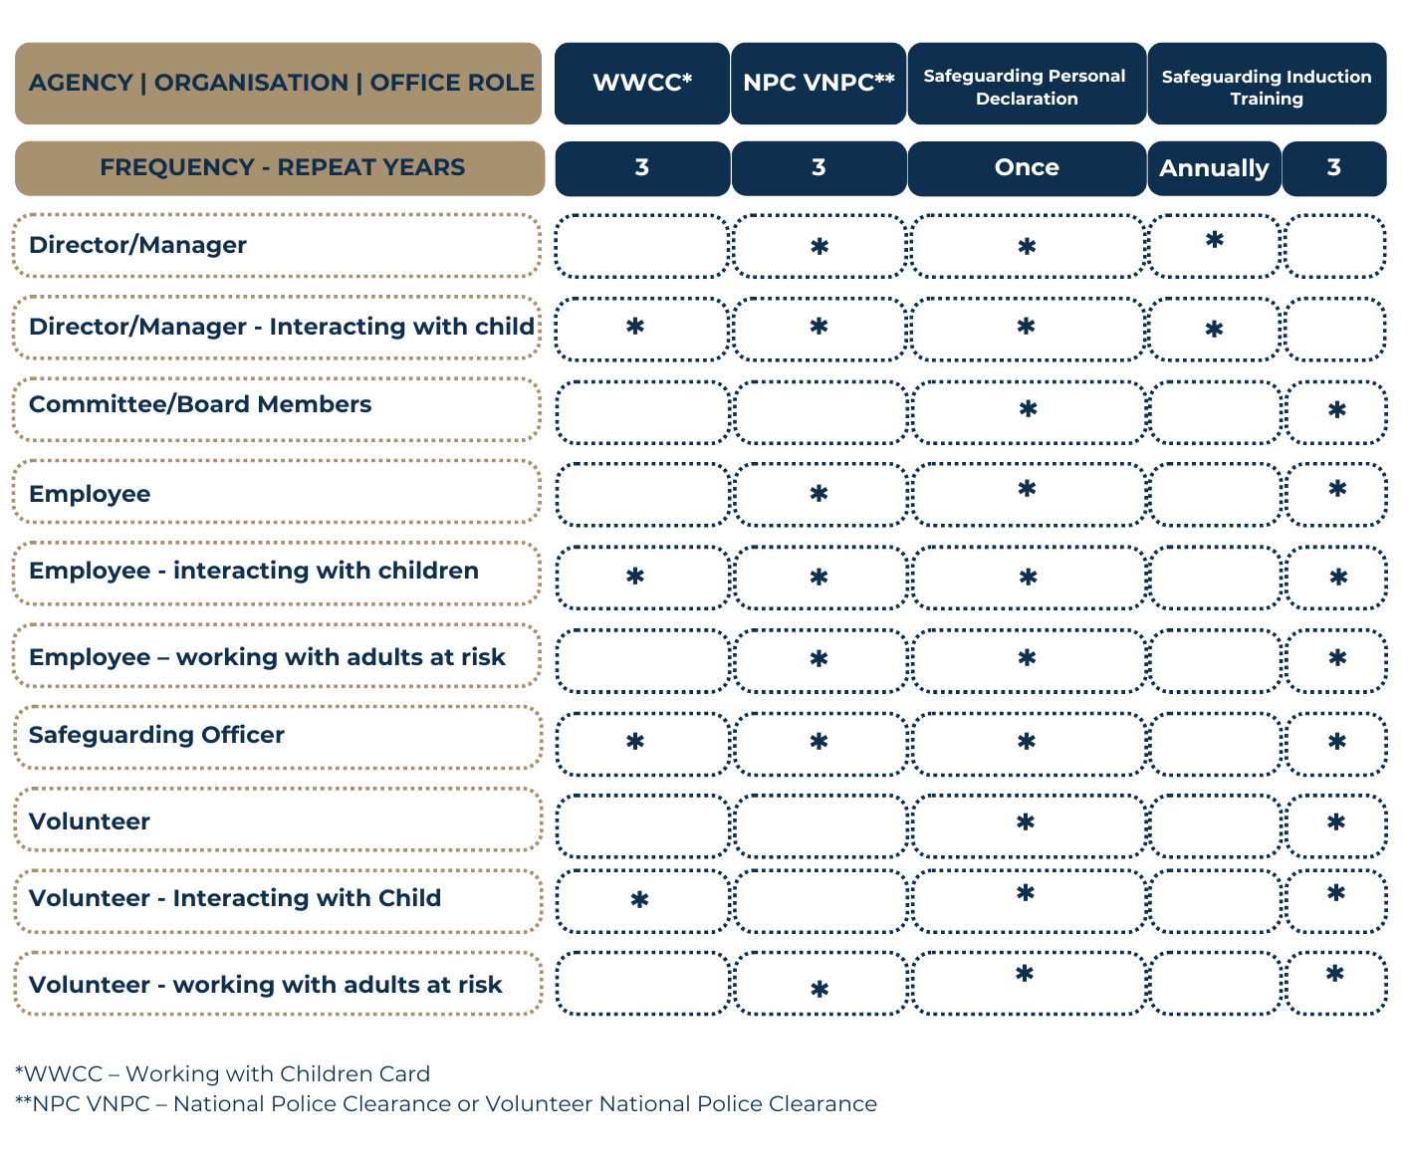

The following matrix sets out the key roles within the Catholic Diocese of Bunbury and the screening requirements for each.

It is not an exhaustive list and should only be used as a guide.

# If unsure of screening requirements, please direct all queries to the Safeguarding Office.