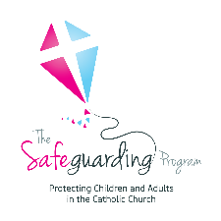

**Catholic Diocese of Bunbury**

**SAFEGUARDING SURVEY**

**(SAMPLE FOR CHILDREN)**

|  |
| --- |
| **Purpose:** |
| To obtain feedback from children about what makes them feel safe and unsafe when attending a parish, church, or church activity. |
| **Who:** |
| Children 5-12 years of age. |
| **Instructions:** |
| This activity should take about 10 minutes to complete.  Advise the children’s parents/carers that you will be conducting a short survey with the children for safeguarding purposes.  Obtain consent from parents/carers for their child/children to participate in the survey activity. Provide parents/carers with a copy of the survey sheet if requested. Explain that the children’s names or other personal details will not be collected.  Encourage parents/carers to be present and assist their child/children if necessary.  Bring children together in a small group – consider using time in either the catechist classes and children's liturgy,  Explain to the children, and their parents/carers that the Church is responsible for keeping children safe when they are participating in church activities, and the Church wants to provide environments where children feel safe and are safe.  Explain that one way to help create safer environments and activities is to ask children what makes them feel safe and unsafe.  Provide each child with a survey sheet. Read each of the survey questions to the group and ask them to provide a response in words or pictures.  Allow time for the children to complete a response to each question before proceeding to the next question.  Collect the completed survey sheets.  Thank the children and parents/carers for their time and feedback reinforcing the importance of giving children a voice, understanding what makes them feel safe and unsafe and that it is ok to tell someone if they feel unsafe or worried. |
| **Questionnaire:** |





**What makes you feel worried when you are at our church?**

**What makes you feel safe when you are at our church?**

**Never**

**Sometimes**

**Always**

**My Safety Matters at _________Church**

**I feel safe at our church. Mark your answer with an X**

**What’s great about our church?**



**What’s not so great about our church?**