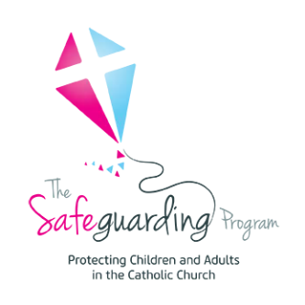Safeguarding Prayer

Lord Jesus,

Hear our voices as we pray for your care and protection. Strengthen and guide us as we strive to make our Catholic communities a safe place for all.

Give us the wisdom and courage to listen with open hearts, see with open eyes, and speak out to ensure children and adults are safe, loved, respected, and cared for.

We also pray for those who have been harmed. Give them the courage to seek the truth and to heal.

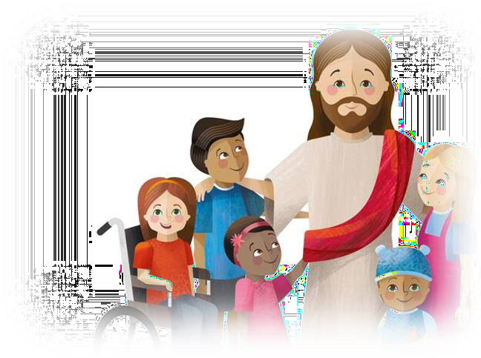May we all strive to understand our collective responsibility to work together to safeguard our Catholic communities.

We ask this through Christ, our Lord, Amen

Safeguarding Prayer becomes uncontrolled once printed. Refer to The Diocese of Bunbury – Safeguarding Office to ensure currency.

Page 1 of 1