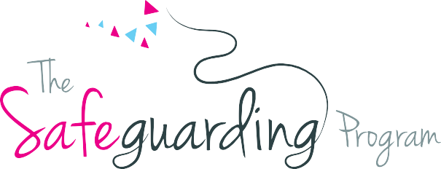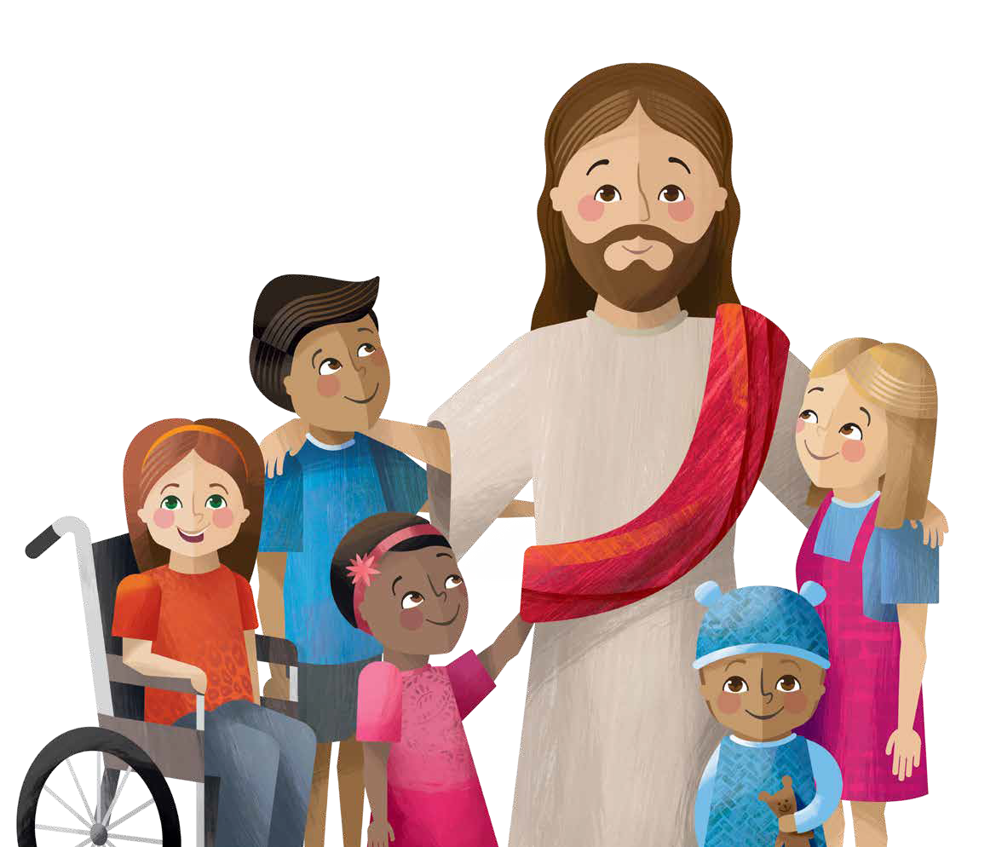

# God gave all children the right to feel safe at all times

Catholic Diocese of Bunbury Safeguarding Office 11 Money Street, Bunbury WA 6230

Phone: 08 9721 0500 Email: safeguarding@bunburycatholic.org.au

# Nothing is so awful that we can’t talk with someone about it

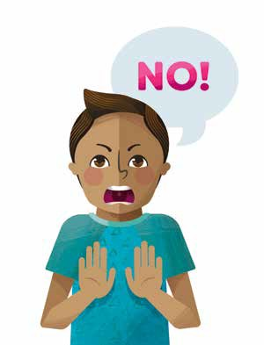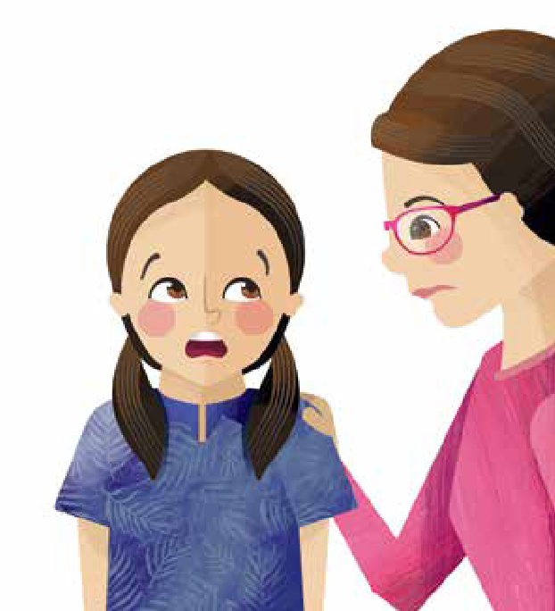

**Children are allowed to break the rules in an emergency.**

If someone makes you feel unsafe, that is an emergency and you should:

**Say No!**

**Get away**

from the person

and...

**Tell someone**

on your Helping Hand.



Catholic Diocese of Bunbury Safeguarding Office 11 Money Street, Bunbury WA 6230

Phone: 08 9721 0500 Email: safeguarding@bunburycatholic.org.au