**My Code of Behaviour for Church activities**

# I will

* Care for others and respect other opinions and decisions
* Co-operate and be helpful to others
* Listen to others and know I have a right to be heard
* Follow the rules set for Church activities by my leader
* Respect others’ social distance (personal space)
* Only use the internet with my Church leader’s permission
* Report anything that worries me or makes me feel unsafe to my Church leader or Safeguarding Officer
* Be treated with respect even if I misbehave

# **3 STAGES OF DISCIPLINE**

1. The Church leader will ask me to stop my behaviour
2. The Church leader will contact

my parents

1. The Church leader will ask me to leave

## God gave all children the right to feel safe at all times

Nothing is so awful that we can’t talk with someone

about it

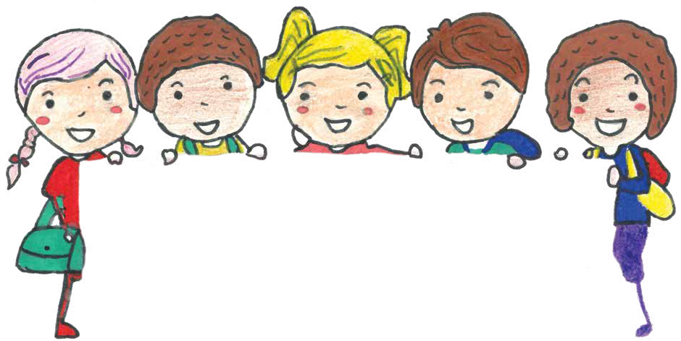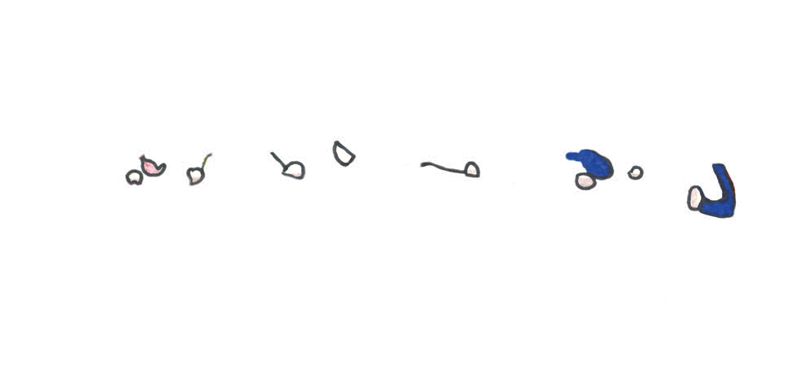

*Design based on the 2017 Child Protection Breakfast Poster Competition winner – Miss Ashlin Kanichai*

Catholic Diocese of Bunbury | Safeguarding Office | 11 Money Street, Bunbury, WA 6230 Phone: 08 9721 0500 | | Email: [safeguarding@bunburycatholic.org.au](mailto:safeguarding@perthcatholic.org.au)