**How to stay connected safely online**

Any interaction with children and young people (under 18 years of age) via a social media platform is to be



Contact the Safeguarding Office to obtain a copy of the

[Parent/Carer Consent Form](https://safeguarding.perthcatholic.org.au/wp-content/uploads/2023/10/FT17_Parent_Carer-Consent-FORM-V2.0_09-10-2023.pdf)

facilitated with parent permission.

There should be no situations where adults are alone with a child. Use a 2:1 ratio (2 adults to 1 child or 2 children to 1 adult).

**OR**



Please provide all children with a copy of ***My Code of Behaviour for*** [***Children***](https://safeguarding.perthcatholic.org.au/wp-content/uploads/2023/08/Safeguarding-Childrens-Code-of-Behaviour-Poster.pdf) ***taking part in Church activities*** poster.



Contact the Safeguarding Office to obtain a copy of the

[Code of Behaviour Poster](https://safeguarding.perthcatholic.org.au/wp-content/uploads/2023/08/Safeguarding-Childrens-Code-of-Behaviour-Poster.pdf)

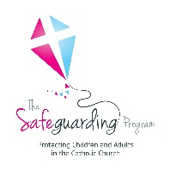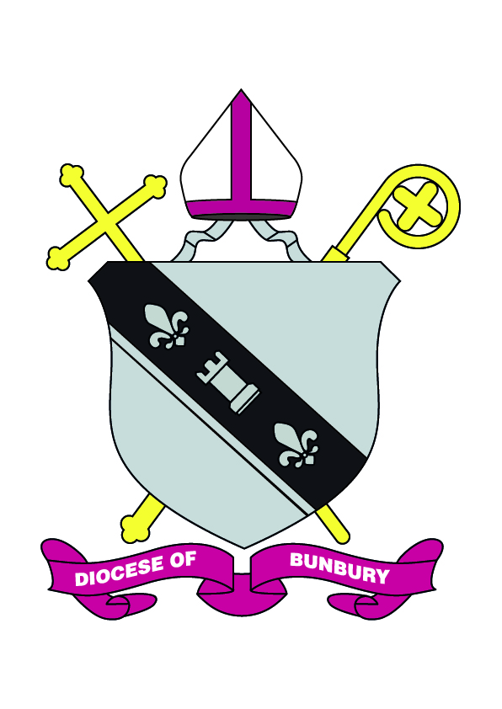

**1**

Keep a written Record of all online Interactions, Group or Activities.



Contact the Safeguarding Office to obtain a copy of the

[Log Sheet](https://safeguarding.perthcatholic.org.au/wp-content/uploads/2024/05/2024-05-13-Online-Interaction-Log.docx)

Send a copy of the record to the parish

or your Safeguarding office.

**Please dress appropriately.**

**Please avoid sharing personal locations.**



**In line with the National Catholic Safeguarding Standard 8.2, leaders are to ensure online environments are used in accordance with the** [**Code of Conduct**](https://safeguarding.perthcatholic.org.au/wp-content/uploads/2023/08/2022_Provincial_Code-of-Ethical-Conduct_FINAL_V2.pdf) **and Safeguarding Policy.**



**More Resources**

Please utilise and share the resources provided by

*The e-Safety Commissioner*

[**eSafetyeducation**](https://www.esafety.gov.au/)

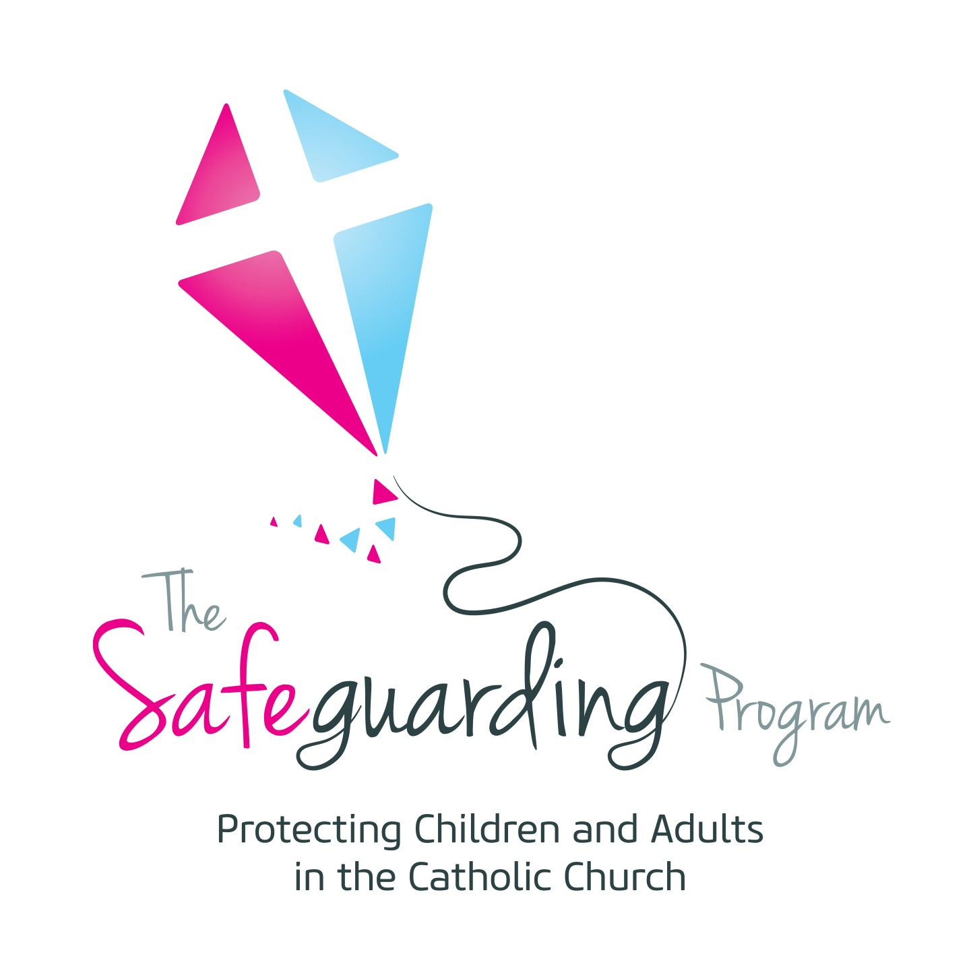

Safeguarding Office. Catholic Diocese of Bunbury

**2**

a. 11 Money Street, Bunbury. WA .6230

p. 08 9721 0500

e. safeguarding@bunburycatholic.org.au