

# How to become a

**Safeguarding Officer**

## Read

JOB DESCRIPTION

## Download and submit

NOMINATION FORM

## Attend

INDUCTION: SAFEGUARDING LEVEL [1](https://safeguarding.perthcatholic.org.au/training/)

**+**

TRAINING: SAFEGUARDING LEVEL 2

## Commissioning

LETTER AND COMMISSIONING PRAYER ARE SENT TO PARISH

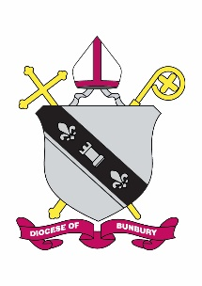

**We welcome all nominations and provide support in the role.**

***Safeguarding is a Collective Responsibility.***

**If you would like to know more, phone 08 9721 0500**

**Catholic Diocese of Bunbury Safeguarding Office**

**a.11 Money Street, Bunbury WA 6230 | ph. 9721 0500**

**e**[**. safeguarding@bunburycatholic.org.au**](mailto:.%20safeguarding@bunburycatholic.org.au)